Work Smart by Link3 IT
Work Smart: PST Automatic Backup

How to automatically backup your .pst files?
IT team has received numerous requests to store users email backup. But it’s not that simple and it would take time and a costly setup for storage and a new mail server deployment. But we are providing you a simple backup feature right now which would ease up your worries a bit.
Safe PST Backup FREE Edition: this small software does everything that its name says. It can identify outlook mail setup and locate your PST file(s) and will provide you options to take a backup and store it in a different location. Screenshot & description follows:
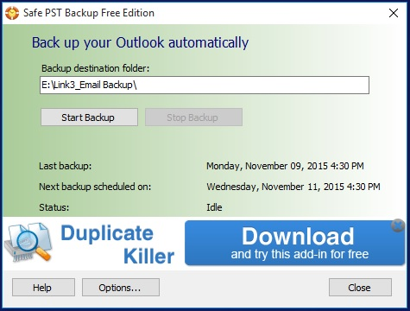
This is the interface after installation, and as you can see, I have configured the software to back-up my email files in a different location other than the boot drive.
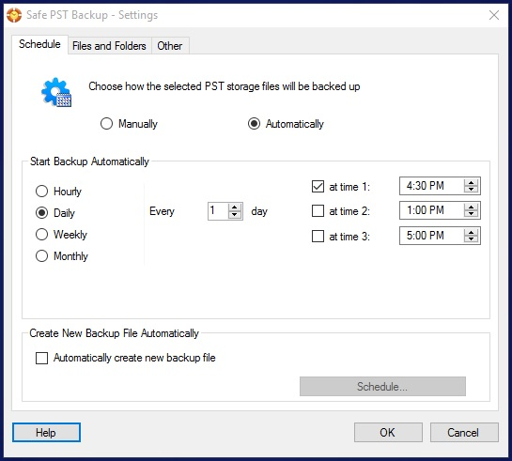
The software also will let you schedule your backup files and you can create multiple files each time it backs up your PST files. I have configured it to back-up my files on daily basis @ 4:30PM in the afternoon.
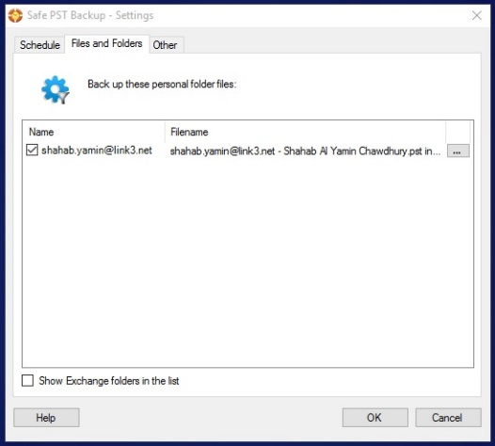
Click on the triple dots on the upper right corner of the filename, the following screen pops up:
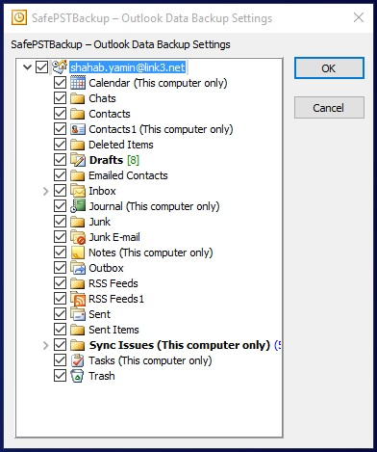
Check the boxes you want, and you are done configuring your PST backup. Also watch the ‘how it works’ video on their website. And this software doesn’t work with RT version of Outlook 2013.
Download & install the free edition: http://www.safepstbackup.com/
AD & non-AD users, both can install this!

For more information

