2014
Shahab Al Yamin Chawdhury
Link3 Technologies Ltd.
12/17/2014
PC Refresh Manual
First thing first, THINGS NOT TO DO:
- Do not receive any laptop that needs data backup.
- Data backup is user’s responsibility, we can facilitate this task, nothing more.
- FORMs must be filled out in each cases
This manual covers only the following circumstances:
- The laptop/desktop needs complete makeover without data migration. In other words, PC refresh using a compressed migration store
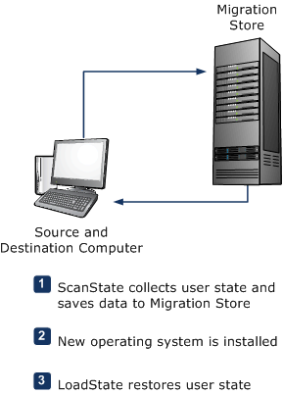
This means that there is an image available to restore the PC at one go for that particular laptop/desktop model. In case unavailability, the laptop/desktop needs complete reinstallation of every software such as:
- Operating System (Win7 x64 SP1)
- Microsoft Office 2013 Pro Plus or Higher
- Microsoft Visio 2013 Pro or Higher
- Microsoft Project 2013 Pro or Higher
- System Center Endpoint Protection
- Foxit PDF Reader
- VLC Media Player
- Video Codecs
- Safe PST Backup FREE Edition
- ImgBurn CD Burner
- Skype Desktop Edition
- Winmail Opener
- JDownloader 2
These images will be @ IT department’s discretion to store, update & use most recent images. Images are created as a standard by using Acronis True Image software.
- This manual does not conform to any defective machine, where this manual will prove to be impractical.

Operating System Installation:
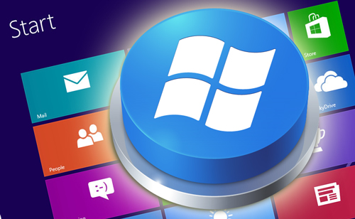
- OS: Operating system is ready made & slipstreamed into specified USB thumb drive for use to make it faster to reinstall operating system into a laptop. Please do not use any other method to complete this task. OS keys are inserted as MAK or KMS form to pre-activate the operating system, and does not need any other means of activation.
- Software Update: only Windows 7 x64 SP1 and SCEP will be updated from the central SCCM server. Other small software’s will be deployed through SCCM as well or in the portal when possible.
- Windows 10 Upgrade: Though Microsoft isn’t pushing KB3035583 update to domain joined machines, but if you find the KB, uninstall it from every unsupported computer from control panel. Specially remove the update from 4050 computers.
- Time: Set the native time to UTC+6, Dhaka time. In the case of AD machine, time server will push & fix the time criteria for each domain joined machine. Manual time configuration is not necessary for AD joined computers.
- Machine Name: Each users machine name will be his/her user ID. i.e L3T1038. Screenshot follows:
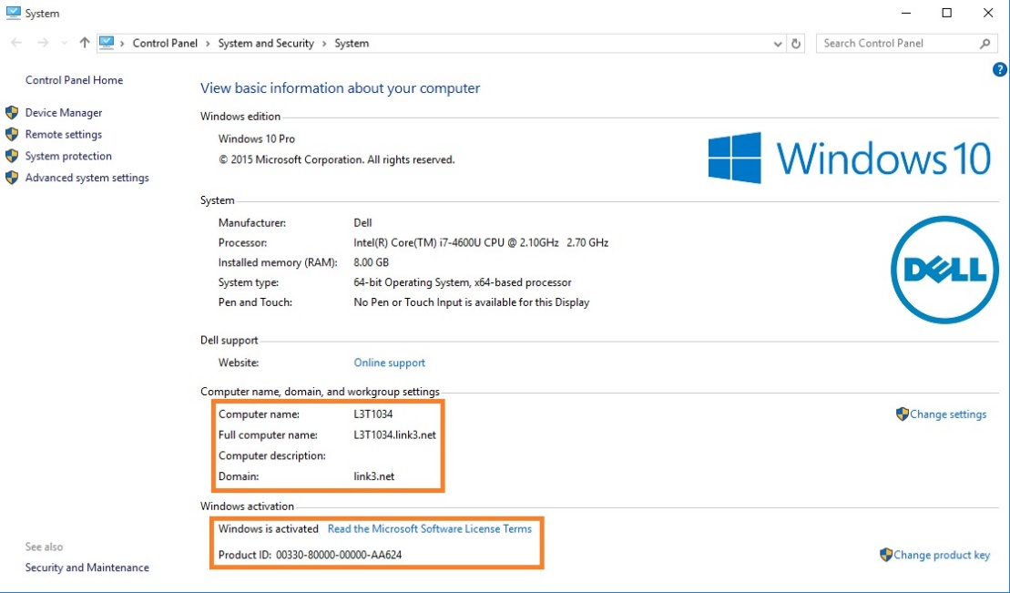
Or change the computer name using the following command in the command prompt, not in the PowerShell:

SET /P PCNAME=Please enter the computername:
- Device Service TAG: in the case of unavailability of the Service Tag for laptops issue the following command to find out the service tag of any computer, providing that the OS completed its booting. Please remember that this service tag can be found in the BIOS as well. If the bottom sticker of the laptop/desktop has been subjected to wear & tear, then it’s a useful method of finding the service tag. This is particularly important if you are assigning the laptop to someone else. Run the command in command prompt and the screenshot, Command follows:
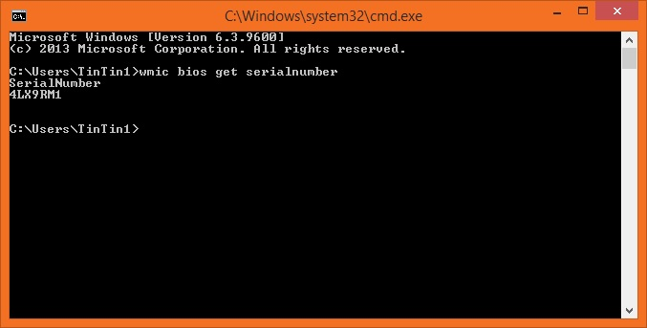

wmic bios get serialnumber

- Device Driver: all drivers must be installed in order to function the machine properly. Respective screenshot follows:
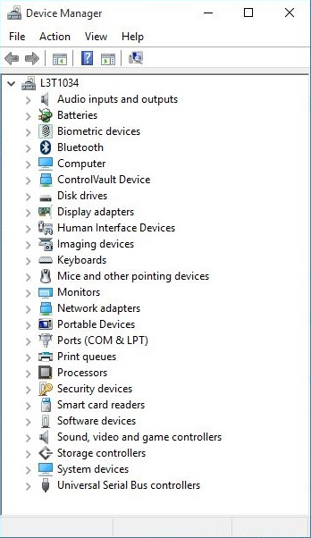
- Lockout: Set the Local Admin password to ‘ch1cken’, unless otherwise specified. After the user enrolled into the AD, this local administrator account will be automatically disabled.
- IP: Each user is provided a real IP. Only assign that or the laptop won’t be available to the hard line. If the IP isn’t available, use the LiFi temporarily. Each floors real IP is static, use the chart to assign IP’s to the corresponding user.
- Printer: Each user be configured the nearest network printer and make it default, floor wise. If the user is available in the AD, then no need to add it manually. GPO Printer will be added/forced to his/account. Make sure to check user is listed in the proper OU. User’s line manager information must be filled accordingly.
- Hardware: Check every laptop component if it’s working or not. Use CPU-Z if necessary
  - Webcam: test if it’s working or not
  - USB Ports: test if it’s working or not
  - RAM: BIOS RAM & OS RAM count must be same
  - Processor Fan: test if it’s working or not
  - Keyboard: test if it’s working or not
  - Touchpad: test if it’s working or not
  - Shortcut keys working to dim the screen brightness
  - Working Keys for Sound control
  - Working Power Button
  - VGA/HDMI output in working condition
  - Hard Disk Drive: Make sure that the hard drive is in basic mode not in Dynamic mode. Backup all user’s data before performing and IT tasks in case of handling dynamic drive. Afterwards, re-partition the drive completely to BASIC mode. Allocate 120GB for first partition, and the rest assign to the second drive.
  - Auto Arrange Icons: Make sure icons are arranged automatically, screenshot follows:
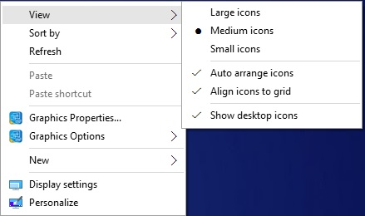
  - Sort By-Item Type: Make sure icons are sorted out by its item type. Screenshot follows:
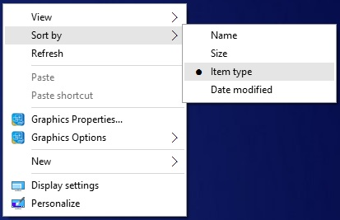
  - Link3.net Domain: Join each computer to domain prior to deliver the laptop computer. This is a mandatory requirement for the organization and for the user.
  - Windows Live Mail: this product/software is part of the Windows component and is not suggested to use for the default mail account. The same mail component also comes with the “Windows Live Essentials”, this is also a discontinued product. Outlook presents many features that are mandatory for the future integrations, which is not offered with the “Windows Live Essentials”, reason why to migrate to Outlook 2013. Educate the user to move to Outlook 2013. Eventually they will need to move to outlook 2013 or higher versions in the coming days.
  - MSCONFIG: run the command in the command prompt using “Windows+R” keys. Turn off the items as the screenshot suggests:
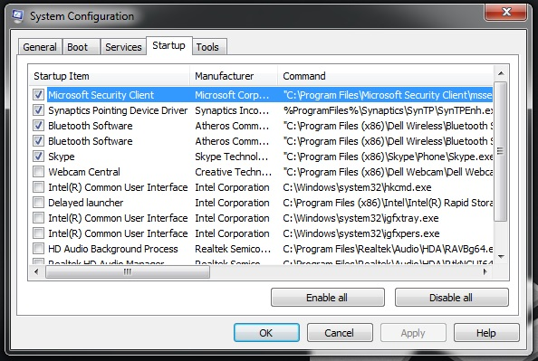
  - Drive Letter: Change the drive letter as per the screenshot
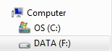
  - Desktop Icon Settings: Only the ticked items should in the desktop (Computer, Network, Recycled Bin), do not turn on any other icons; this will make sure the desktop stays clutter free. Screenshot follows;
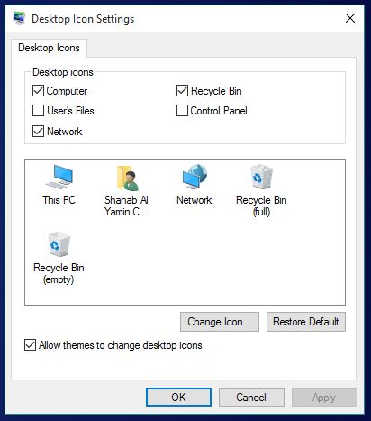
  - Highlight Newly Installed Programs: Turn it OFF; follow the screenshot
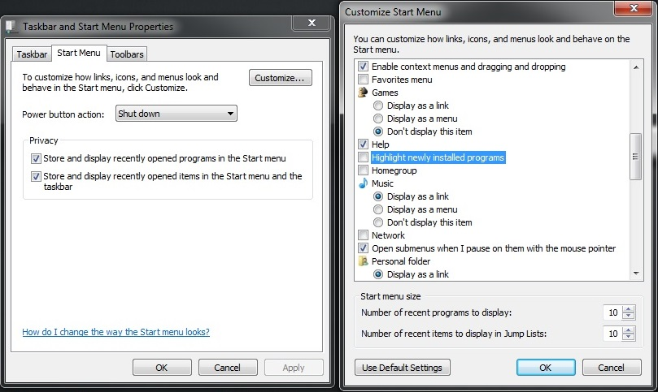
  - Bing Search Engine: make Bing as a home page for the browser
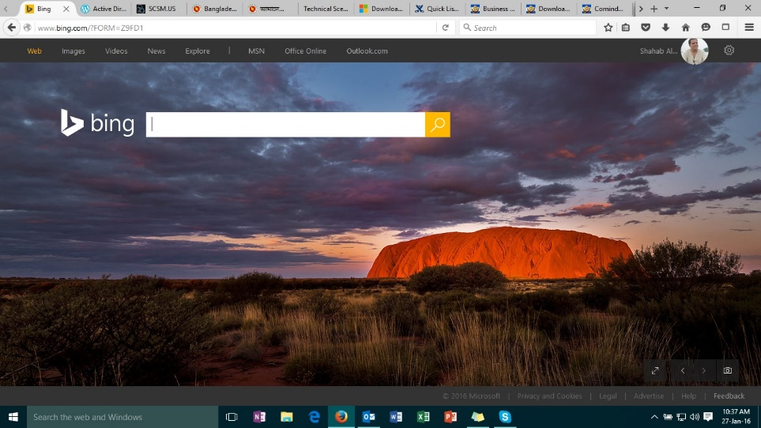

Microsoft Office 2013 Pro Plus Edition
Microsoft Office 2013 is provided by default. No previous versions will be delivered to any office employees. If the machine cannot handle such requirements, then please move the user to a new machine. The following software components will be installed by default for every employee of Link3:
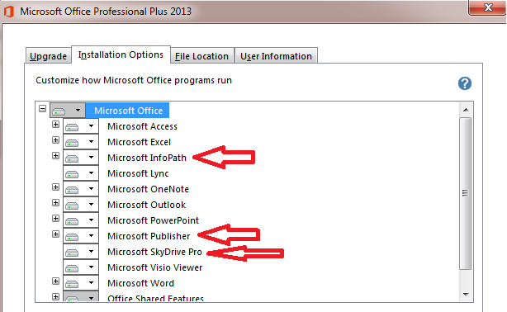
In no circumstances, the following components of Office 2013 be installed:
- Microsoft InfoPath
- Microsoft Publisher
- Microsoft SkyDrive Pro
Every other component should be installed to run from computer and would be available for first use. Where required, Visio & Project of same version be installed, but it’s not a general practice.

Microsoft Office 2013 Standard Edition
Microsoft Office 2013 is provided by default. No previous versions will be delivered to any office employees. If the machine cannot handle such requirements, then please move the user to a new machine or even Office 2013 Standard Edition. Remove the X marked items from installation
In no circumstances, the following components of Office 2013 be installed:
- Microsoft InfoPath
- Microsoft Publisher
- Microsoft SkyDrive Pro
Every other component should be installed to run from computer and would be available for first use. Where required, Visio & Project of same version be installed, but it’s not a general practice.
Screenshot follows:

Other software’s
Install, configure & update the following software at will:
- System Center Endpoint Protection
- NOC Required Software’s
- WEB Required Software’s
- DEV Required Software’s
- Video Codecs
- Safe PST Backup FREE Edition
- Winmail Opener
Safe PST backup software should be installed after the Outlook mail configuration completes, and the backup file should be placed into a different partition other than the boot drive.
Outlook Profile Backup: Take the backup from the registry by running regedt32.exe or regedit.exe.
- Export path for Office 2013: HKEY_CURRENT_USER>SOFTWARE>Microsoft>Office>15.0
- Export path for Office 2016: HKEY_CURRENT_USER>SOFTWARE>Microsoft>Office
Screenshot of the profile location for Office 2013
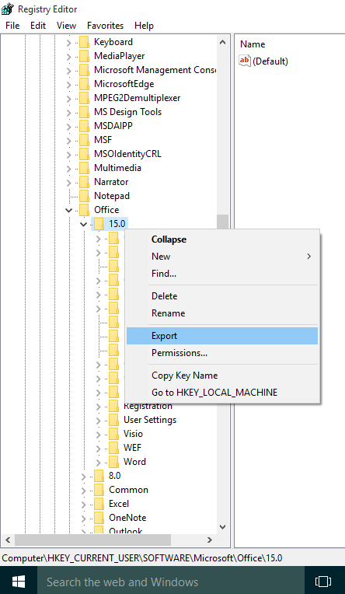
Mozilla Firefox Plugin: Make sure the following plugin is installed in Firefox under “Plugins”. This is a future requirement and cannot be ignored.
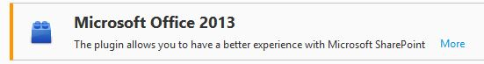
KMSPico Start Menu Items Creation: While installing the KMS Activator, do not install the start menu items. If created the folder will show up in the start menu and users will have access to it to tinker with this. Screenshot follows:

Office Outlook Automatic Send/Receive Mail Delay:
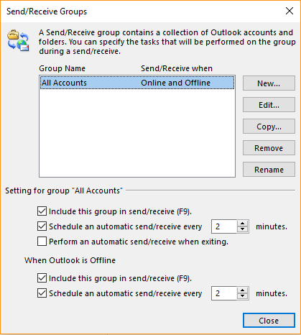
Make sure it is not set to 30 minutes.

