This framework includes a hierarchy of Link3’s IT department’s capabilities. This is used in research and can be used by organizations to assess maturity/capability levels. The goal of this building framework is to have proactive support system throughout the organization. A simple process could be followed as below framework
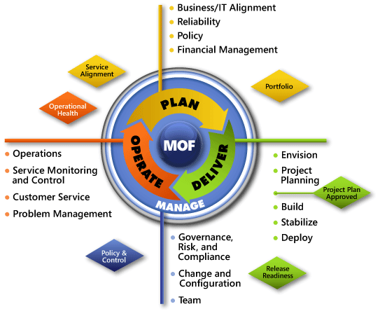
Figure 1: Microsoft Operational Framework, Basic Delivery

IT-CMF Overview Matrix
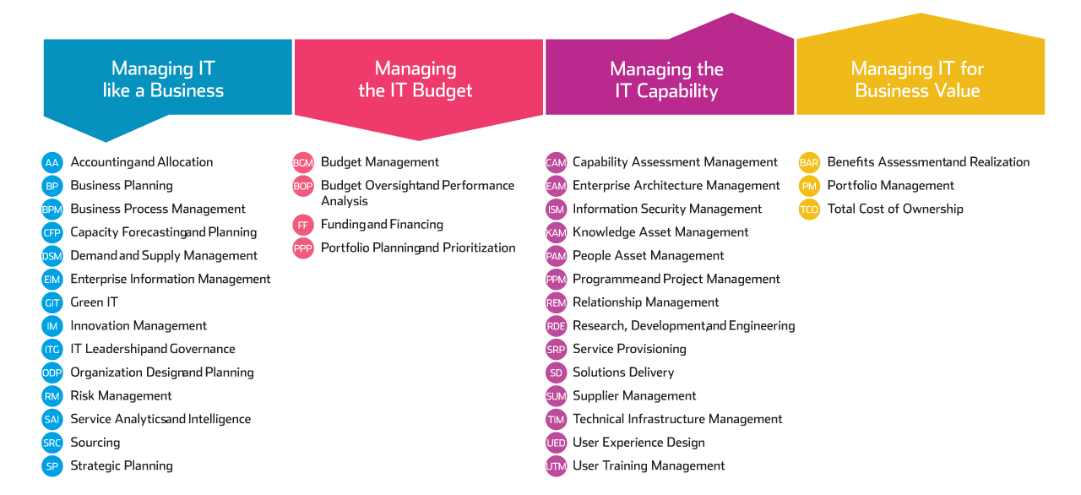

Infrastructure/Platform Technology Initiatives
Initiative Type | Key Features, Capabilities, Benefits | Vendors And Products
PC Hardware & Operating System Upgrades | - Improved performance, reliability, security, manageability, productivity improvements  - Notebook, desktop, thin-client | - Microsoft Windows 7 x64 Professional  - Dell, HP, Apple, Toshiba, Lenovo, Fujitsu, Acer, Gigabyte  - Intel
Server Hardware & Software Upgrades | - Virtualization, consolidation, clustering  - Data center optimization  - Improved performance, reliability, manageability, security  - Multi-core, 64-bit, RISC/Itanium, x64  - Web servers, application servers, DBMS servers, data warehouse servers, infrastructure servers, high performance computing servers | - Microsoft Windows Server, Kali Linux, CentOS, Red hat  - Dell
Infrastructure Management / Networking | - Asset inventory/management, OS management, configuration management, change management, systems management, software distribution, application packaging  - Directory services, group policy objects  - IPV6, LAN, WAN  - VOIP - voice over Internet protocol | - Microsoft System Center Configuration Manager, MDOP, Active Directory  - Active Directory, PaperCut, GFI, Acronis
Storage | - Digital storage of business data and documents  - Archival, records management, tape backup, SAN, NAS, disk arrays, iSCSI, fibre channel  - Capacity management, performance analysis, storage provisioning, quota management, event management | - SharePoint integrated with Lync & Exchange Server  - Microsoft Exchange, Microsoft SQL Server  - DELL EqualLogic SAN
Security | - Security planning, assessment, incident/breach management  - Identity and access management, encryption, smartcards, authentication, authorization, patch management  - Firewalls, antivirus, anti-malware, anti-spyware, network access control, information and data rights management | - Microsoft System Center Endpoint Protection, System Center Service Manager  - Authentication: By AD, Mikrotik  - VeriSign  - Barracuda
Application Development / Architecture | - Improved software quality, integration, usability  - Custom developed software  - Rapid application development  - Middleware, application server  - Web services, Service-Oriented Architecture, SaaS (software as a service)  - Enterprise architecture (EA) | - Microsoft .NET, Visual Studio  - .NET  - .Net  - Java/J2EE/EE, Ruby on Rails, PHP, Python, Perl  - BizTalk Server, Application Server  - Microsoft On-Premise Cloud Platform
Compliance, Governance, Risk | - Methods and software to ease compliance with regulations such as HIPPA, Sarbanes-Oxley, Basel II  - ITIL, COBIT, Six Sigma, CMM, ISO 17799/9000, PMBOK  - Maturity models (Microsoft™ Infrastructure Optimization Maturity Model)  - Portfolio management, IT-business alignment, balanced scorecard, service level management, risk management  - Business continuity: disaster planning / recovery  - IT governance, policies, internal audit, monitoring | - Not Required  - ITIL & MOF, PMBOK-5  - ITIL & MOF  - ITIL & MOF, PMBOK-5  - ISO 20000, 27001
Outsourcing | - Outsource IT and business processes, applications, infrastructure, or initiatives to reduce costs and improve results  - Infrastructure management: helpdesk, on-site support, desktop management, data center services  - BPO - business process outsourcing  - Offshore services  - Application outsourcing, web hosting | - Various Vendors  - System Center Service Manager
Wireless/Mobile | - Wireless e-mail, mobile access to line-of-business applications, unified communications,  - VPN, mobile remote access, telecommuting  - Handheld devices, smart phones, PDAs  - Wireless LAN/WAN, 802.11n, WiMAX, CDMA, UMTS, GPRS, EDGE | - Microsoft Exchange Server, InTune Server  - RIM BlackBerry, Nokia, Apple iPhone, Samsung, Google  - 3Com, Cisco Systems, Nortel Networks, Siemens  - Equant, AT&T, MCI, BT, Sprint, Verizon

Business Technology Initiatives
Initiative Type | Key Features, Capabilities, Benefits | Sample Vendors And Products
Office Productivity Software | - Word processing, spreadsheets, personal databases, presentation graphics software, personal information management, note-taking, task and project management, document creation and publishing | - Microsoft Office 2013  - WPS Office
Messaging / Collaboration | - E-mail, calendaring/scheduling, task management, unified communications  - Real-time collaboration, presence, instant messaging, web conferencing  - Social computing, blogs, wikis  - Team workspaces, project management, discussion threads, document workflow | - Microsoft SharePoint, Exchange, Live Meeting  - Skype for Business Communications  - Microsoft Yammer  - Microsoft Project Server 2013
Content Management | - Document management, web content management, document imaging, records management, digital asset management  - Knowledge management, information management  - Intranets, Extranets, Portals | - Microsoft SharePoint
E-commerce / Internet | - Web sites for external business information dissemination, marketing, sales transactions, etc.  - Web storefronts, shopping cart management, taxation, personalization, transaction management, settlement and product visualization  - B2B, B2C, AJAX, mashups | - Microsoft IIS, Commerce Server
Business Process Mgmt / Integration | - Process modeling, monitoring and management  - Workflow, business rules, automation, electronic forms  - BAM (business activity monitoring)  - EAI (enterprise application integration) | - Microsoft BizTalk Server, SharePoint Server  - Captaris Workflow, SharePoint  - Pegasystems, SAP, TIBCO, webMethods, BEA Systems, SeeBeyond, GXS, Sterling Commerce
Business Intelligence / Data Mgmt | - Database management systems (DBMS), data warehousing, data marts, online transaction processing (OLTP)  - Master data management, data quality, metadata  - Financial planning, corporate performance management, reporting, analytics, dashboards, scorecards, enterprise search, ETL, OLAP, query | - Microsoft SQL Server, PerformancePoint Server  - Teradata, IBM, MySQL, Ingres, PostgreSQL, Sybase  - Business Objects, Informatica, Cognos, Information Builders, MicroStrategy, SAS
Business Applications (Vertical, LOB) | - Wide variety of specialized software that helps organizations streamline business processes and improve results (enhance efficiency and effectiveness) | - Numerous products/vendors for every business function and industry
CRM | - Customer Relationship Management  - Sales force automation, marketing campaign management, customer information management, order entry, customer service management, customer analytics, product configurators  - Hosted CRM | - Microsoft Dynamics CRM
ERP / Supply Chain | - Enterprise resource planning: supply chain management, operations/production management, inventory management, planning/scheduling, finance/accounting, human resource management, product management, warehouse management, logistics, purchasing, order entry, etc. | - Microsoft Dynamics

