Work Smart by Link3 IT
Work Smart: What IT is doing for you?

How Neatly Can You Work? uction
The following are recommended best practices for keeping the staff and public computers within the company, secure and functioning properly. Most of the information provided here are guidelines and do not deal with specific procedures. Please contact the IT Helpdesk for more details.
1. Laptop/Desktop Operating System
The Bugatti Veyron is the fastest, most powerful and most expensive sports car in the world. Windows is the most expensive PC Operating System, so it is the fastest too?
The Windows operating system, may be a great product, but it's not perfect, nothing is. Windows experience by the users: “It is arguably the fastest, most intuitive, and most useful consumer desktop OS on the market today.” Since most Link3 users are windows users, IT is providing the “Windows 7 Professional SP1 x64 edition” as a primary OS selected for the mass users across the organization. In the near future every laptop will be developed equipped with “Windows Enterprise” edition which adds more value to the company. Please seek help of IT, if you have proper justification not to use the provided OS. And do not change your laptop’s OS without prior communication to IT.
2. Software Updates: Link3-IT will maintain an inventory of network connected domain laptops, printers and other devices as well. This inventory will be maintained by the System Center Configuration Manager 2012 R2. And the same software will be used to update laptop OS, Office 2013 and Antivirus Signatures from a central location, so that no machine would ever go to internet for its updates.
And please do not forcefully shutdown your computer while the updates are being installed. Eventually it will start over again to install the downloaded software.
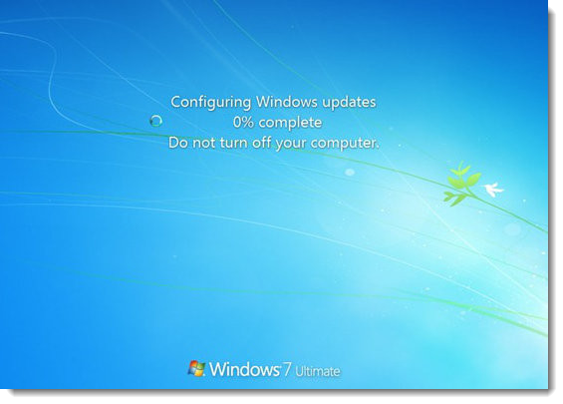

3. Drive Partitioning: Your computer’s hard drives are prepared in a way that OS and Program Files container is expected to hold at least 30GB of data. So the OS partition is made of 100GB, and the rest of the free space is allocated to one single partition. There will be no exceptions of this as the requirements for having domain joined PC’s will have access to your data drive and can grab or fetch data from designated drive partitions. Screenshot follows:
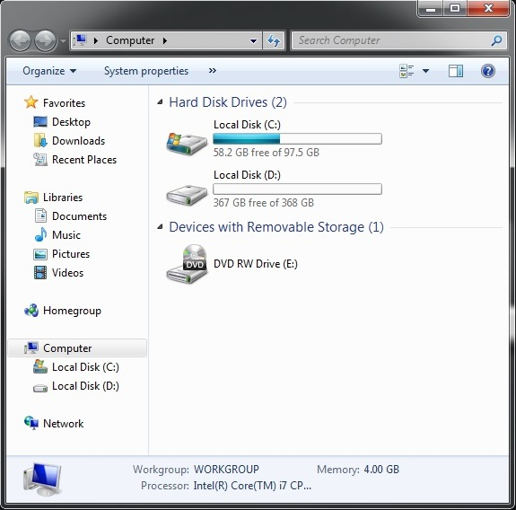
4. Remote Desktop: Remote desktop is primarily used for connecting your computer via a secure channel and recipient’s authorization, for the purpose of either servicing or troubleshooting purposes. Configuration follows:
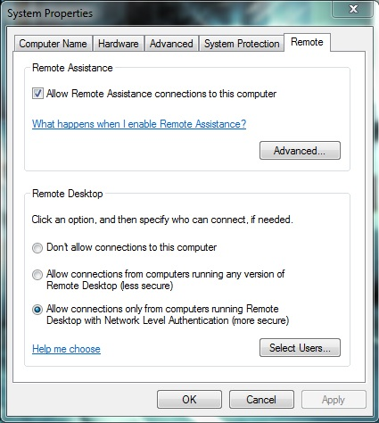
5. Antivirus: IT is providing System Center Endpoint Protection (SCEP) for your overall anti-viral protections & spam, DOS attacks & macro attack protections. Therefore the organization is unifying the effort across the organization, minimizing different antivirus purchases for every laptops. Screenshot follows:
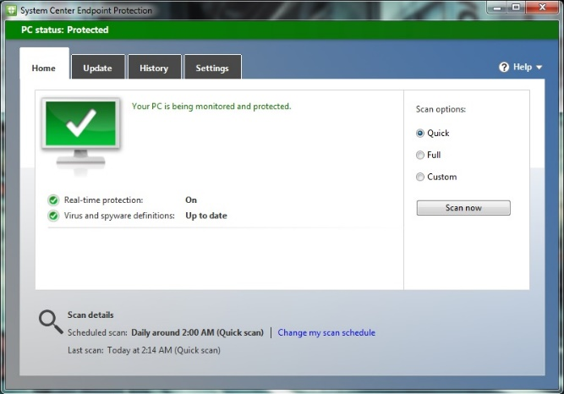
6. Security in the Office: the operating system itself brings the Firewall within the OS and primary source of attack is blocked to the OS.
7. BitLocker Encryption: as mentioned earlier, windows enterprise edition will provide data level encryption. This will allow your data to be safe even if your laptop is stolen. No one can retrieve your data from your stolen laptop if BitLocker is enabled on your drive. BitLocker requires TPM chipset built into your laptop. Boot-time Screenshot follows:
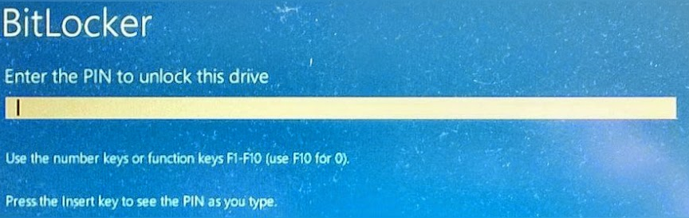
8. Microsoft Office 2013 Professional Plus: Microsoft Office 2013 Professional Plus is being provided to every Link3 staff, with the following components:
- Microsoft Word 2013
- Microsoft Excel 2013
- Microsoft PowerPoint 2013
- Microsoft Outlook 2013
- Microsoft OneNote 2013
- Microsoft Publisher
Any other than the mentioned components, like Visio, Project & other required software’s, please consult with IT.
9. Microsoft Office Outlook 2013: Where your Inbox resides, create individual folders using persons or company names. This hierarchy creation is the best practice of managing your mails. Your outlook inbox should look like this:
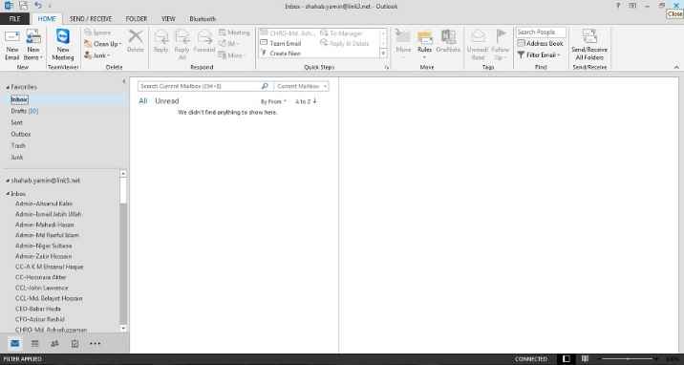
Uncluttered and free from errors. Move your read mails into desired folders, and keep your inbox clean and empty.
10. Adobe Flash Player Installation: Adobe flash player installation comes with a McAfee antivirus offer, please uncheck this optional offer before you click the yellow colored Update Now button.
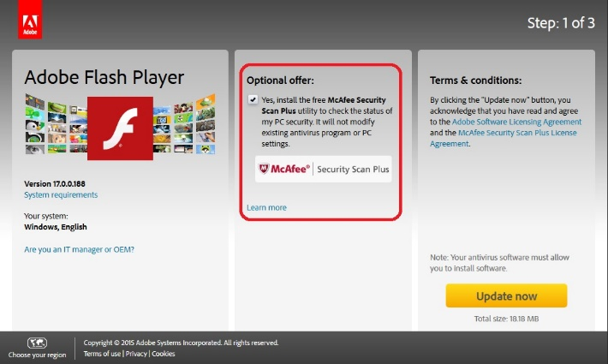
11. Internet Browsers: IT is providing one extra internet browsers, which is Mozilla Firefox due to internal application compatibility. Also built-in Internet Explorer is good for browsing internet. Please do not install more than 2 internet browser, adding more browsers will only reduce your laptops performance. Make Bing your homepage and search engine and earn browsing points, and later on use the points to earn OneDrive storage, as I’ve done it.
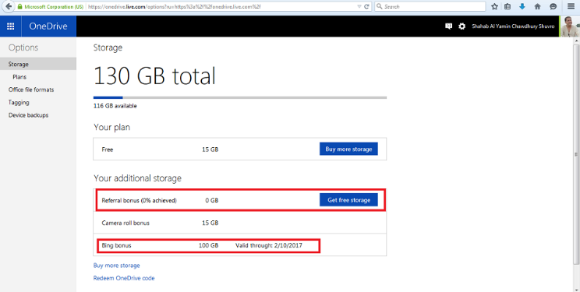
12. Mozilla Firefox Extensions: a new breed of browser injectors are seen within the past couple of months and been reported worldwide. Screenshot follows:
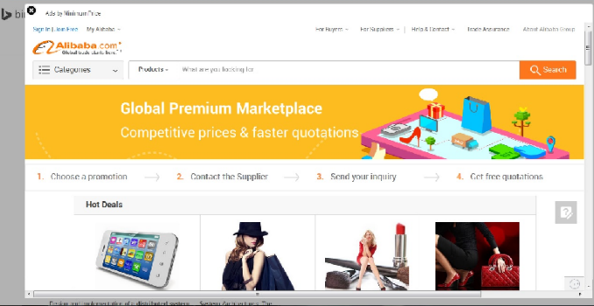
These malwares hijacks the screen of the browsers, presenting a link for e-commerce sites. Its not likely that all of these links are not harmful, but they enable backdoors. Especially Firefox & Chrome are vulnerable to these marketing software’s. These software’s will not ask for your permission to install. So, uninstall and block/disable these Firefox extensions:
Disable & Remove these extensions:
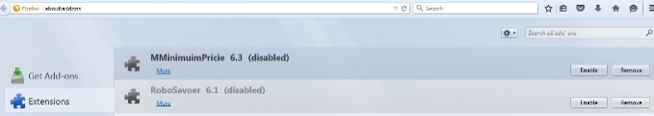
And then uninstall the “” marked in red extensions. These are potential threats to your laptop.
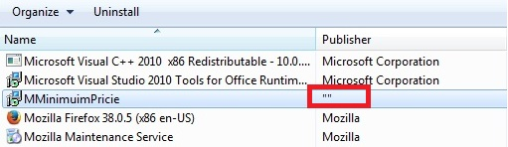
13. Smart Card Login: Soon IT is going to introduce the Smart Cards to login into your laptop, floor access etc. the same card which will allow you into the intranet, will also be used to allow you into each Link3 establishment. Only after your laptop migrated to the Link3 Domain, you will have added login credentials to access the company’s intranet. Screenshot follows:
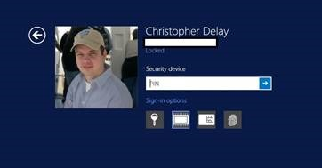
The same login credentials like the password, virtual smart card (certificate), hard coded smart card and your fingerprints; all of these credentials can be used to login into the Intranet. Windows may verify or may prompt you to type your PIN or to insert your smart card into the card reader for trying to access high impact business documents:
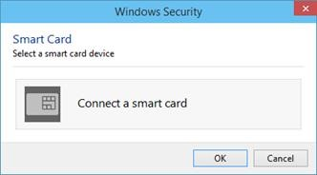
14. Change Your Password: make a habit of changing your password after a significant time been passed, say 70 days. Your domain password can be changed by using the three finger salute (Ctrl+Alt+Del):
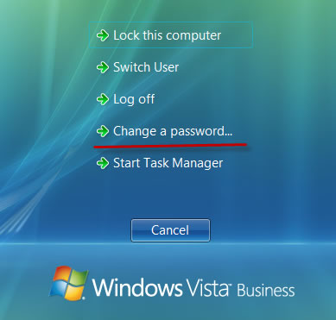
The domain introduced to Link3 will bind your computer to each future resources provided by IT. So, change of your SSO password will change all over domain joined services & resources shared, like Exchange Mail Server, SharePoint Collaboration Server, Lync Communication Server etc. These will not be loosely coupled services.
15. Microsoft Lync 2013: Lync is currently provided to first line of managers who are readily experiencing its videoconferencing capabilities. Though it’s in limited functionality (without PSTN & BYOD).
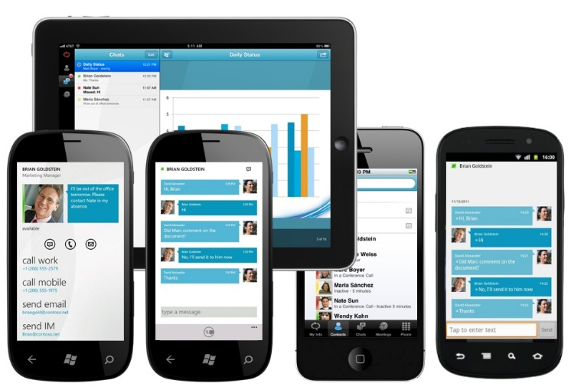
Lync will be available to nearly everyone, as a target for reaching the status of “one person one computer” level. Screenshot follows:
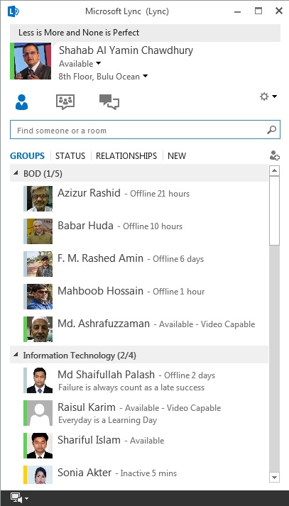
Microsoft Lync is useful for IM, Group Chat, Video Conferencing, Remote Desktop Support, PSTN to Lync and vice versa communication and much more. Long distance training and conferencing within the network is also a goal and been achieved. Screenshot follows with IT team in a 4-way video conferencing:
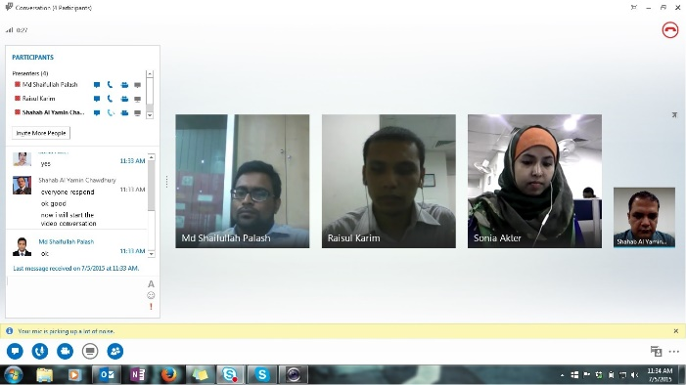
The conversation history gets stored into outlook. When the session ends, you will get this message:
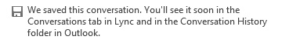
16. Work Folders: IT will gradually initialize windows Work Folders for individuals and for teams as well. This work folder is useful for transmitting documents internally. Remember, you can only access this if you are within domain joined computers.
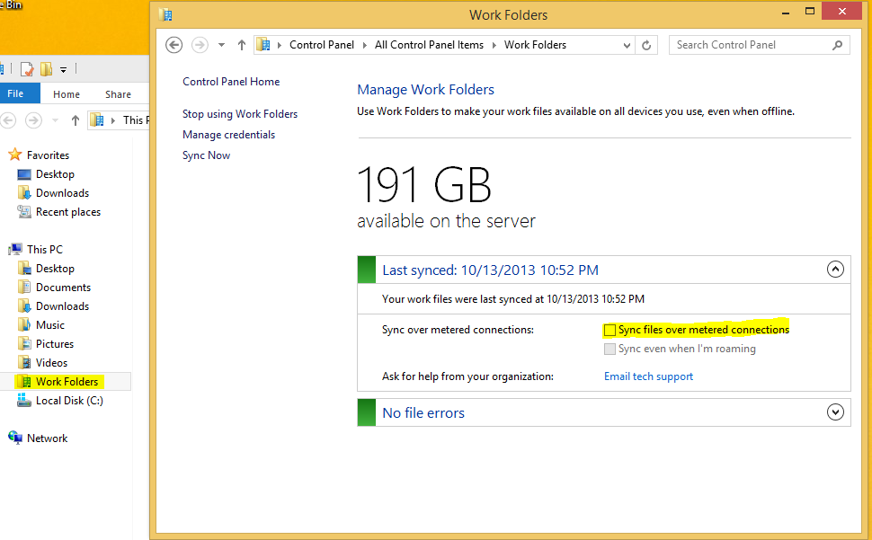
17. DirectAccess: Each domain joined machine will have a secure connection to the local server resources by eDiscovery of which enables user to access corporate resources:
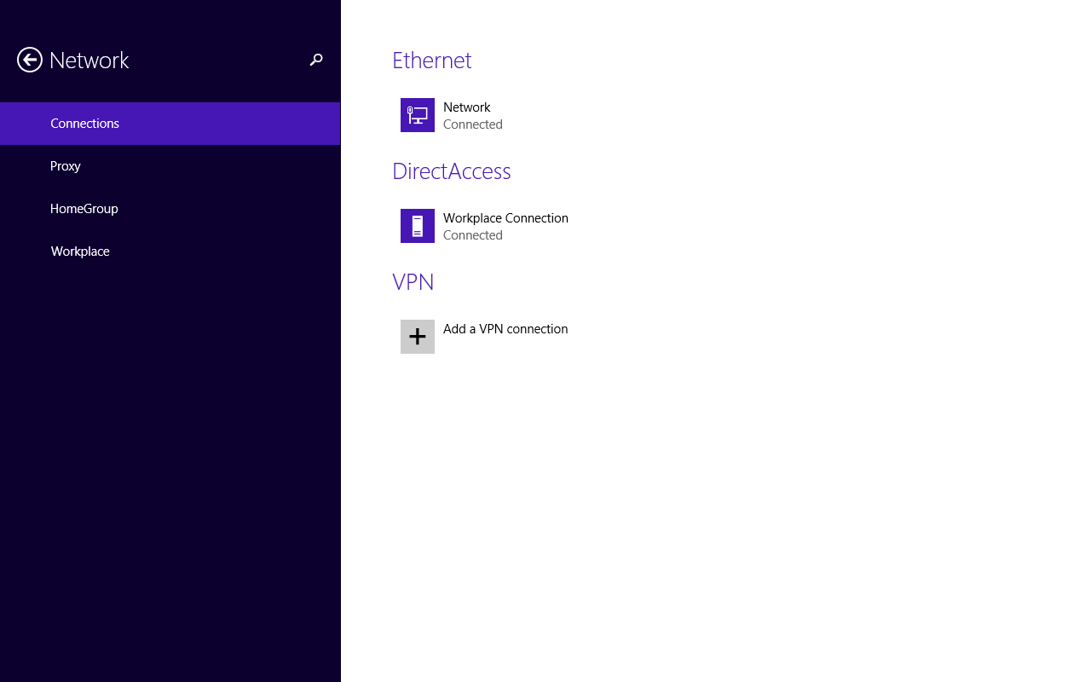
18. SharePoint Sites: IT is soon to deploy SharePoint parking site for Link3, and probably be internally discoverable as //l3web, screenshot follows for a team site:
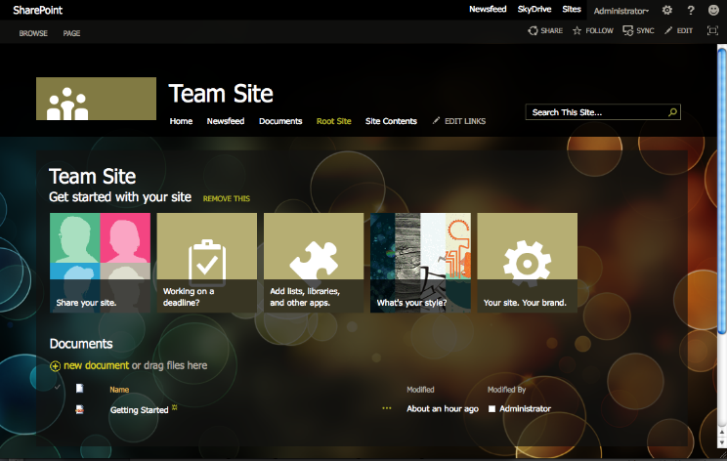
19. Prevention is always better than cure: We will sequentially move to operational excellence by 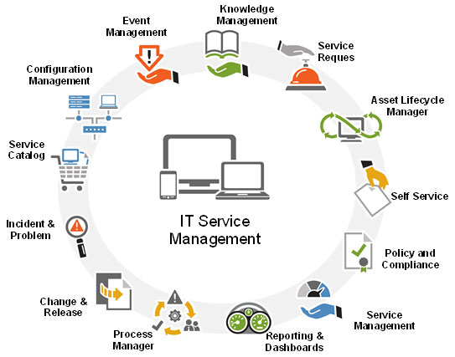
adopting to ITIL and ITSM which will help us work more efficiently using less time.
Also please refrain yourself from any unauthorized activities that could invoke the following causes:
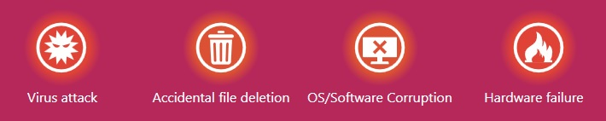
Training: IT has provided following training materials to HR, interested? Call Nigar Sultana @ 2009
- Word 2013 Essential Training
- Excel 2013 Essential Training
- Project 2013 Essential Training
- Outlook 2013 Essential Training
IT Responsibilities: IT will configure and maintain following services for you (shortlisted):
- Primarily IT is focusing on Laptops/Desktops, Printers (desktop & Network), Projectors and its servicing needs etc.
- Your desktop operating system
- Your e-mail setup, profiling and offline archiving/backup
- Antivirus & installed software’s and individual/team requirements

For more information

Do consult your IT Team for further assistance

desktop Support:

