2/12/14

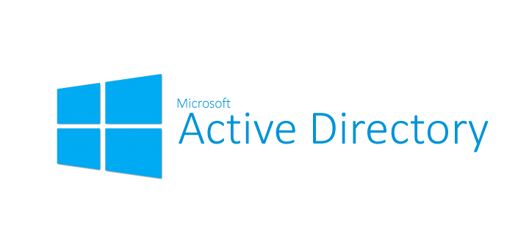

What is Active Directory?

Rendered Benefits?

Category: IT Knowledgebase

Active Directory Basics
The Active Directory is a database system that connects all of the individual machines within a network, makes information easy to access from anywhere, and allows the network administrators to grant permissions to specific users. While the first two elements are important for the purposes of running a business efficiently, the most critically valuable element of using Active Directory for any business is the control that it provides to the network administrators.

What is Active Directory?
For starters, all of the user account and password information for the entire network is stored in a single, protected location, which is beneficial to a company’s security. By using Active Directory to connect all of the users and machines on a single network, the IT team is able to oversee the activities that go on throughout the entirety of the company from a single access point. This means that you can monitor productivity, the transfer of information, and anything else that occurs on your network.
Without Active Directory, the computers in an office are set up in workgroups: individual devices that are all running on the same Local Area Network (LAN). This means that each computer is a standalone machine; they don’t communicate with each other easily or efficiently, and require users to go through an authentication process every time you want to exchange information from one to another. There is no global account that will link all of the machines to one another.

Why Does my Company Need Active Directory?
If your office used Active Directory, all of the machines would be connected on a single domain, which means all of the information is stored in a central location, not locally on the individual computers’ hard drives. The domain is controlled by a global catalog/database, which keeps track of all of the devices that are registered to the network. The global catalog stores the IP addresses, computer names, and users, so that the global administrator can oversee everything that happens on the domain. In order to access someone else’s computer, a user would just need that computer’s name, because everything is already linked on the back end.
BCN is already using Active Directory, everything is already permissioned from the domain controller. This means that the network administrator has already told the domain controller what permissions to assign to each user to access which resource. This makes all digital communication more efficient, because everything is easily accessible, and information is readily available by using role based access control.

What are the benefits of Active Directory for BCN?
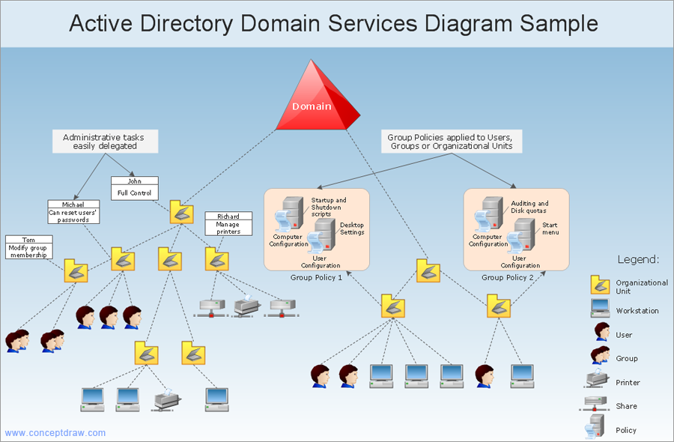
bluecloudnetworks.net
Figure 1: The domain design of Bluecloud Networks
Resources are stored in containers in active directory like users, computer etc. and each have it own importance for example Users have user info, Sites has sites running under active directory. Schema is very important container, tracks all active directory objects Help in creating new objects.

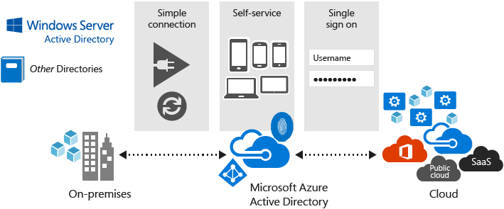

Figure 2: Basic Foundation of Active Directory
Active Directory is a state-wide authentication directory that supports enterprise systems, provides contact information and scheduling integration, along with providing mechanisms for centralized desktop management. Though the encrypted transmission and the asset management cannot be seen the Active Directory Project for BCN was targeted to migrate all of these environments into a single AD forest, which is currently in production and rendering the following benefits:

- Increased scalability.
- Active Directory is standards-based, using Kerberos authentication and Lightweight Directory Access Protocol.
- The speed of which it is able to provide domain names. Unified access to resources by supporting a uniform naming convention. It is tightly integrated with DNS services for all its operations, which will provide better in identifications and migrations.
- Single user name and password – Network Identification
- Automatic password expiration after certain period of time
- Simple identity management as we can view all user information. Improved knowledge management, using Active Directory like a phone book to look up resources.
- Password synced between AD and LDAP Directory Services
- Anywhere login, as AD has a cache on every connected computers
- Reduce overhead through standardization
- Improve services through centralized management capabilities
- Provides foundation for the following AD related services:
    - Exchange Server
    - SharePoint Server
    - Skype for Business Server
    - Dynamics CRM/ERP
- End-to-end security for network transmission
- Improved individual workstation security, not easily penetrable, making it more secure from hackers.
- User Rights assignment onto a folder/file by using role based access control
- User mode configuration works best with AD Sync
- Central Software Deployment, such as EndPoint Security (Antivirus)
- Central Patch Management for each EndPoint
- Managing Trust relationship with internally joined member servers
- Multimaster site replication capability
- Interactive remote access with integrated security encryption for supporting the joined computers
- Maintain and monitor the workstation installations, assets etc. It makes the task of network administration simpler by maintaining a central repository of information.
- Computer policies are enforced to automatically update workstations.
- Central storage provided for individuals and departments
- Backup and restoration services for central storage
- Server storage space for user documents
- Backed up data on Departmental drives (not yet deployed)
- Lower departmental cost because infrastructure is managed and maintained by IT on a single console
- With Active Directory as a central point for business data, information can be shared with other business systems such as internal software’s like MIS, HR etc. enabling greater cooperation within an organization.
- Independent or remote sites can connect to centralized Active Directory server, leading to a centrally managed database.
- Automatic network health report generates network health status for transmission
- Cost savings and increased networked availability by simplifying infrastructure
- Making it compatible with other operating systems other than Windows.
- Virtualization of servers made it severely cost effective
- Virtualized server software is severely cost effective in licensing terms as all Microsoft based virtualized licensing is free (server services running in virtualized environment).

In BCN’s current scenario IT virtualized over 17 VM’s and its rounded cost is 22K BDT per VM, and we can increase the VM count as long as the hardware resource is available. Which’s licensing is perpetual and BCN holds the license benefits.
Hyperconvergence is always suggested based on VM density and scalability, another reason to procure higher core’s if and when possible, so that a company can get benefit of having less Hardware & Software to manage, and it’s also cost effective.

