Work Smart by Link3 IT
Work Smart: NetSetMan, Your Network Profile Switcher

Managing Multiple Network Profiles?
Sharing with you all a small but effective software that would ease your life a bit.
IT was observing that every now and then technical people needed to enter new IP addresses into their laptop’s network interface; as they are roaming around into different networks and needs to access the internet. Now this small tool will be able to ease that task a bit by managing those networking needs.
The freeware software is named “NetSetMan”, short for network settings manager. Which can handle multiple profiles, including your default printers. Please follow the below link to download the tool: http://www.netsetman.com/en/freeware
Install the downloaded software by clicking on the 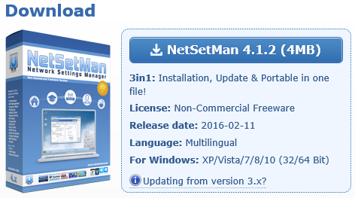
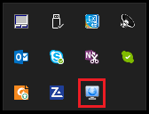
Blue button (NetSetMan 4.1.2 (4MB)). After installation you will be presented with the following UI:
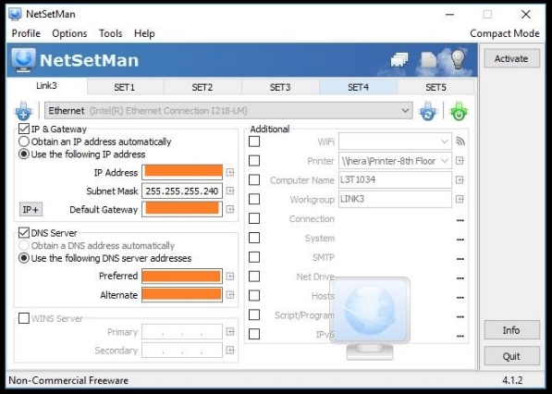
Now as you can see, with the free version you can create 6 profiles only. Pro version has unlimited features. Each profiles gets saved automatically. Select the network interface (RJ45/WiFi), put in your desired IP’s and you are done saving your first profile.
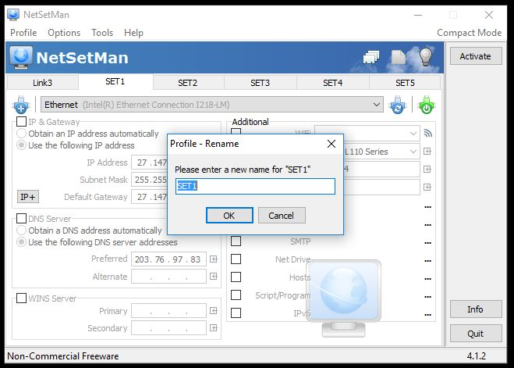
Double clicking on the tabs will let you rename the profile name. Configure any WiFi, like Link3’s LiFi by clicking the Wireless con on the “Additional” pane:
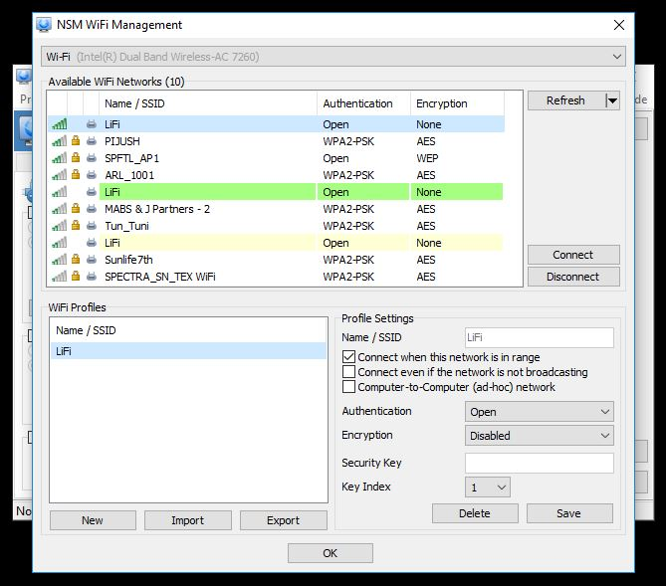
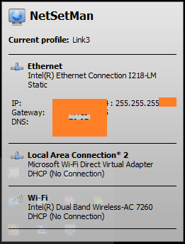
Click OK and you are done selecting the LiFi network. This tiny program can be started when windows starts, and will reside in the taskbar minimized. Hovering on the icon will show the current activated Profile:

For more information

