Work Smart by Link3 IT
Work Smart: Receiving attachments as ‘’winmail.dat’’ files?

Receiving attachments as “winmail.dat” files?
We have a small solution for this frustrating problem. But why the attached files are delivering and you are also receiving not as the original attached files but as “winmail.dat” files.
There are two explanations for it, and two solutions to it as well.
Solution 1: Now let’s get to know the program a bit. There is a tiny freeware program that can read the ‘winmail.dat’ files. The program called “Winmail Opener”. All you have to do is to install the program, save the attached file from your email and open it with the Winmail opener program by clicking on the “Open file…” link. Current version is 1.6. Screenshot follows:
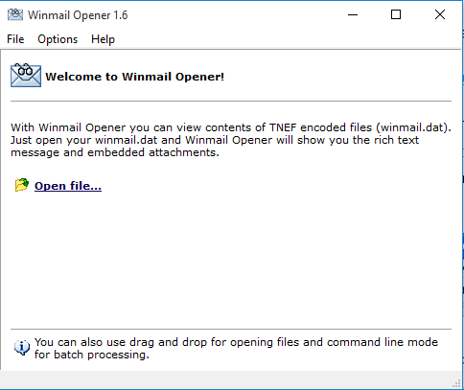
The latest version can be downloaded from the following link:
http://www.eolsoft.com/freeware/winmail_opener/
Solution 2: Whichever Outlook version you are using, IT is providing office version 2013, meaning most of you are already using the Outlook version 2013 whose laptop is serviced by IT. Since we are using Zimbra as our primary mail server and to be compatible with Zimbra email services, you could turn your outlook to send mail not as an HTML format, but as the PLAIN TEXT format. This tweaking would eventually send your attached files to your recipients as it’s attached. No winmail.dat conversions. Outlook 2013 can be configured to send plain text mails continuously, screenshot follows:
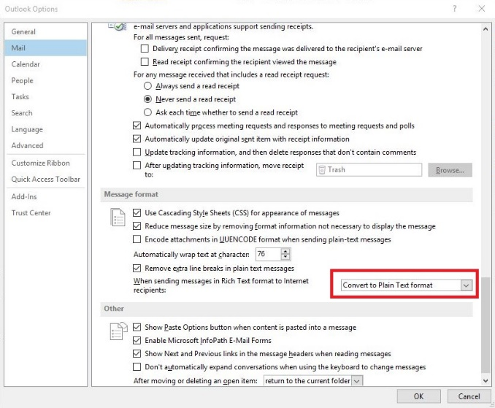
Go to File> Options and then ‘Mail’ > Message format, and change the default format to “Convert to Plain Text Format”. Click ‘ok’ to make the change permanent. If you don’t want a permanent change, you can configure each new mail you are creating, and format the mail sending options to “Plain Text”. This is a workaround for new mails only.
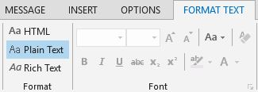
But doing so, you will lose all the rich text formatting features. Happy emailing…

For more information

Do consult your IT Team for further assistance

desktop Support:

